**Unit 0 Investigation 3**

Name: ____________________________

Period: _____

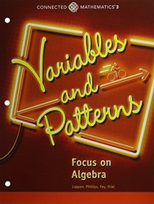

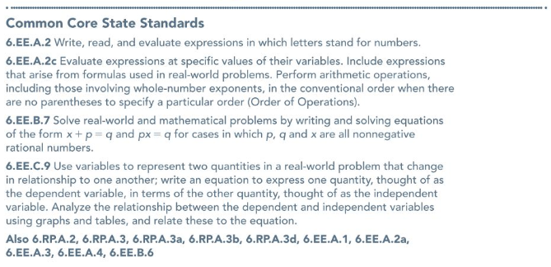

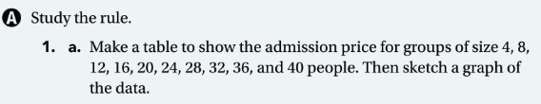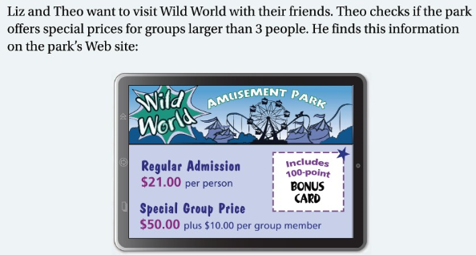**Problem 3.3:**







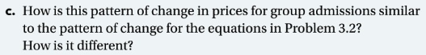





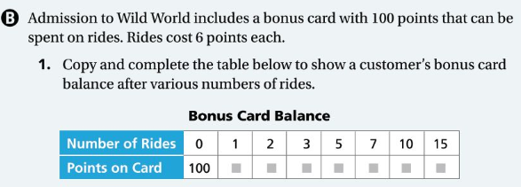







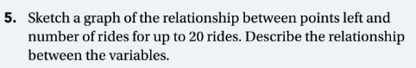

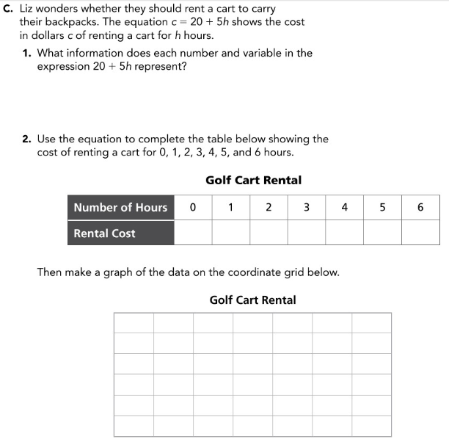







**Investigation 3.4 Notes**

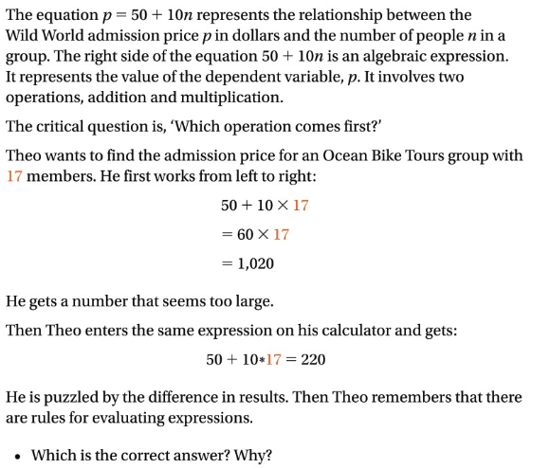

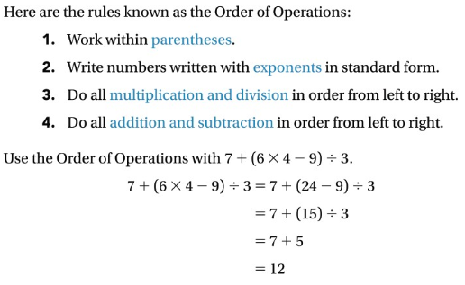

**Problem 3.4:**

